Doing mobile development is the biggest challenge in terms of running localhost application to the Mobile Devices and seeing the change reflection to the mobile device after local changes.

**NgRok** is the widely used library to expose secured public url to the localhost server which can be run on devices using internet. And since this public url is linked with the localhost server so local changes will automatically get reflected to the devices as well.

I tried NgRok and was able to run the WebComm on iOS devices and Android devices. This finding will help team to fix devices issues very quickly.

Below are the steps:

1. Connect with your home wifi
2. Install ngrok: run following command **npm i -g ngrok**
3. run UI:  **npm run bw** (<https://localhost:443>)
4. run server: **npm run sw**
5. run following command: **ngrok http 443 -host-header="localhost:443" (if you face any issue, refer** <https://dashboard.ngrok.com/auth> to set the authtoken**)**

Screen similar to the below screen will appear:

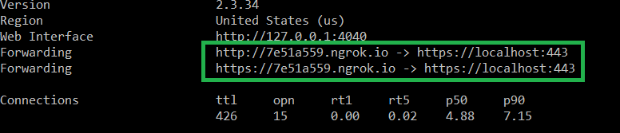

1. Inside green box, copy https url and open it with chrome browser of Mobile Device
2. You will see web comm application will be loaded
3. Now just reload the browser after doing local changes and you will see changes gets reflected to the application

Below are the screenshots which I have captured running localhost application on iPhone and Android device:

Steps to debug remote web application:

1. Assuming you have followed steps to expose local server to internet and accessing web page from Mobile Device in the other mail
2. Run: **npm i -g weinre**
3. weinre server will need machine IP and any port (which is free) to run
4. run: **npx weinre --httpPort 1234 --boundHost 192.168.29.14** (assuming machine ip is 192.168.29.14 and port is 1234)

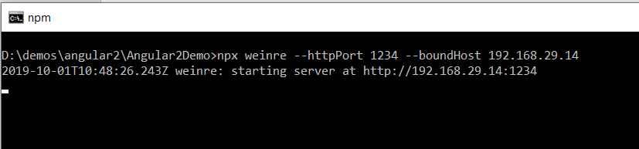

1. open **ngrok.yml** file (can be found under C:\Users\sunban\.ngrok folder)
2. Replace tunnels section by below content:

tunnels:

first:

addr: 443

proto: http

second:

addr: 192.168.29.14:1234

proto: http

1. Run: **npx ngrok start -all**

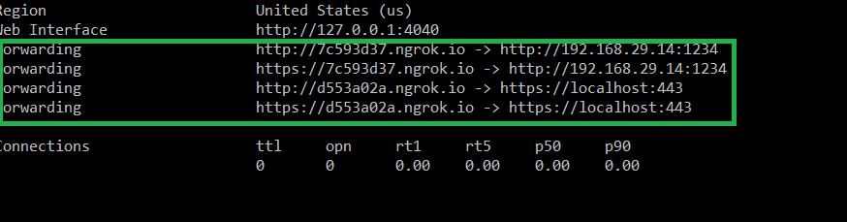

1. Add the following tag under <head> section of your code:

<script src="**https://60616b9d.ngrok.io**/target/target-script-min.js"></script>

where <https://60616b9d.ngrok.io> will replaced by <https://7c593d37.ngrok.io> as per above screenshot

1. Open <https://d553a02a.ngrok.io> on your Mobile Device
2. Open <https://7c593d37.ngrok.io/client/#anonymous> on your laptop. You would one device will be added under Targets. Select your target and use Elements tab to inspect the styles. Not only styles you can also monitor Network/Console, can also check browser resources.
3. Have Fun!